
Department | FED
Subject | DSA-2
Academic Year | I-III Semester(2025-26)
Faculty Name | N.M Deepika
Student Name | CHADA HASIKA
Roll Number | 2520030372
Branch | CSE
Couse Outcome | 1
Case Study Topic:Razorpay Backend Monorepo — CI Build-Graph Cycle Suspected
Work Done Summary:
This case study focuses on analyzing a backend monorepo build system similar to Razorpay's CI/CD infrastructure, where a build coordinator performs topological sorting on service dependencies before scheduling parallel builds. During CI execution, the build process reported a suspected cycle in the dependency graph, causing the pipeline to fail.
The study investigates the dependency relationships among multiple build targets including auth, payments, kyc, ledger, fraud, notify, admin-ui, customer-ui, and gateway. Using graph traversal techniques, the dependency graph was modeled as a directed graph and analyzed to identify cyclic dependencies. DFS-based cycle detection with color marking was applied to detect back edges responsible for the cycle.
The analysis successfully identified cycles in the build graph, reconstructed the exact cycle path, and evaluated different edge-removal strategies to break the cycle with minimal impact on dependent services. The study demonstrates how graph algorithms can be effectively applied to dependency resolution problems in large-scale CI/CD systems.
Implementation Details:
- Constructed a directed dependency graph from the given build manifest.
- Represented build targets as vertices and dependency relations as directed edges.
- Applied DFS-based Topological Sorting using WHITE, GREY, and BLACK color states.
- Traversed vertices in alphabetical order to ensure deterministic DFS execution.
- Detected cycles using back-edge identification when a GREY vertex was revisited.
- Reconstructed cycle paths using parent pointers maintained during DFS traversal.
- Identified the following cycles:
o admin-ui → payments → auth → ledger → fraud → notify → gateway → admin-ui
o ledger → fraud → ledger
- Modified the topological sort algorithm to return the exact cycle path instead of a generic exception.
- Evaluated candidate edge removals to break the cycle.
- Determined that removing the edge gateway → admin-ui provides the least disruption while eliminating the cycle.
- Verified that the dependency graph becomes acyclic after removing the selected edge.
- Generated valid topological ordering for the corrected dependency graph.

Result: Output
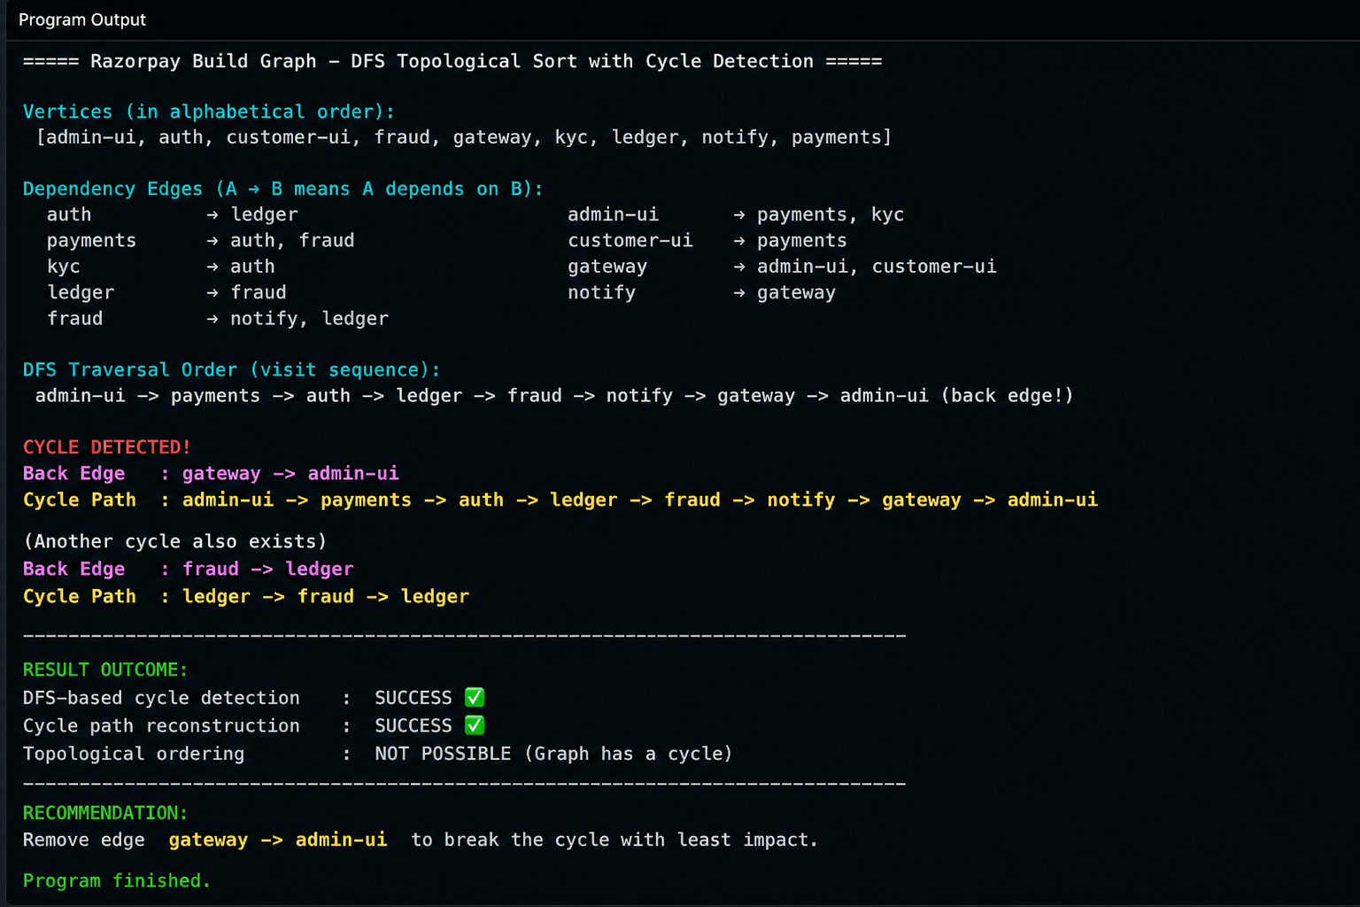
Key Features of the Code:-
Implements DFS-based Topological Sorting for directed dependency graphs.
• Uses a 3-color marking system (WHITE, GREY, BLACK) to track traversal state.
• Detects cycles through DFS back-edge detection.
• Maintains parent pointers to reconstruct detected cycles.
• Returns either:
• A valid topological ordering if the graph is acyclic.
• The exact cycle path if a cycle exists.
• Supports efficient dependency validation in CI/CD systems.
• Uses adjacency-list graph representation.
• Performs traversal in O(V + E) time complexity.
• Suitable for build dependency management, monorepos, package managers, and task scheduling systems.
• Provides detailed cycle reporting for easier debugging and maintenance.

Conclusion:
The implemented DFS-based topological sorting algorithm efficiently detects cyclic dependencies in build graphs and accurately reconstructs the offending cycle. By utilizing color marking and parent tracking, the algorithm provides meaningful debugging information rather than generic failure messages. This approach is highly effective for CI/CD dependency management systems, ensuring reliable build scheduling and faster identification of configuration errors in large-scale monorepo environments.

GitHub Link:

Student Signature | Faculty Signature

